**Southwest Florida History:**

**A Rough Land and Rough People**

**Peter Fortune**

**2014**

**Revised 2016**

**This Page Intentionally Left Blank**

**Contents**

|  |  |
| --- | --- |
| Introduction | 1 |
| The Gold Coast: Ft. Myers to Naples | 3 |
| The Mosquito Coast: The Ten Thousand Islands | 19 |
| The Empty Coast: Cape Sable to Flamingo | 31 |
| References | 33 |

**This Page Intentionally Left Blank**

**Introduction**

This brief history divides southwest Florida into three sections: The *Gold Coast*—Charlotte Harbor down to Naples; the Ten Thousand Islands or *Mosquito Coast*—Marco Island down to Cape Sable; and the *Empty Coast*—Florida Bay and the Keys.

Anyone interested in the history of southwest Florida should read three books. *A Land Remembered* by Patrick Smith, first published in 1984, is a novel of pioneer life in the Everglades area—a life on the frontier where cattle died of asphyxiation when swarms of mosquitos clogged their nostrils, where desperados escaping justice in settled areas continued their predations, where plume hunters devastated the rookeries so northern ladies could wear elegant hats, where families fought snakes, alligators, famine, hurricane and floods to survive, and where Seminole Indians hid in the Everglades from federal soldiers and white predators. It gives an excellent flavor of life in the pioneer days of the Everglades.

The second is Peter Mathiesson’s trilogy on the 1910 killing of a sugar cane farmer in the Everglades City-Chokoloskee Island area of the Mosquito Coast. This fascinating series tells the story of the Everglades through the eyes of people who settled there in the 1870s and after. Mr. Watson, owner of an island in the Ten Thousand Islands, was a desperado who fled to the area to escape the law and became a successful sugar cane grower. He was a quiet man who could snap into violence in a moment and was much feared in the area until the entire village of Chocoloskee murdered him—yes, the village! The story is told from three vantage points: the first volume, titled *Killing Mr. Watson*, tells it from the view of Watson’s Everglades neighbors; the second volume, titled *Lost Man’s River*, tells it from his family’s perspective; and the third volume, *Bone by Bone*, is from Watson’s own point of view. It is a great series, to which Mathiesson was so devoted that in 2010 it was rewritten and published in a single volume called *Shadow Country.*  Most people just read *Killing Mr. Watson*, but each is worth the time.

The third is the environmental classic *Everglades:* *River of Grass*, by Marjory Stoneman Douglas. First published in 1947, it describes the fragile Everglades ecosystem and man’s encroachments. This book was instrumental in the 1947 formation of Everglades National Park.

There are many other local histories written by people who lived the rough life in the Everglades. Prominent among those is “Totch” Brown, a local good boy whose tales of alligator hunting in the 1960s and drug running in the 1970s will keep you sitting around the campfire till the wee hours.

**The Gold Coast: Charlotte Harbor to Naples**

The Gold Coast begins a bit north of Fort Myers, in Charlotte Harbor, a harbor devoted almost entirely to the avocations of fishing and boating. Life there is primarily island life, slow moving and easy. Communities there have long histories and are closely knit. While not far from Fort Myers as the crow flies, these communities are remote because the roads are indirect country roads and small ferries serve the islands.

The central feature of Charlotte Harbor is Pine Island, a twenty-five mile long strip separating the mainland on the east from the barrier islands on the west. On the east side of Charlotte Harbor the communities are Punta Gorda and Burnt Store in the north, and Cape Coral and Fort Myers in the south. On the west side there is Gasparilla Island, with its charming town of Boca Grande, then the islands of Useppa, Costa Caya, Captiva, and Sanibel.

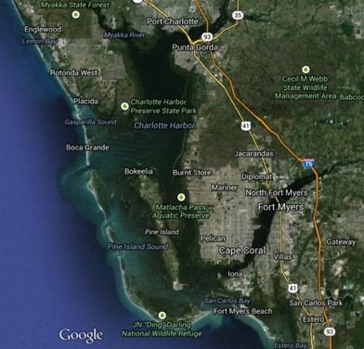

**Charlotte Harbor and Pine Island Sound**

First we will travel down the east side of Charlotte Harbor.

*Punta Gorda*

Located at the northeast corner of Charlotte Harbor, Punta Gorda (“Fat Point”) is the seat of Charlotte County (formed in 1921) and, therefore, a center for this lightly populated area. Its population of 16,762 in 2000 has grown from the original settlement by the Howard Brothers in 1875, when the town was informally called Trabue after Isaac Trabue, a Kentucky lawyer who came to the area specifically to start a town. In 1886 the Florida Southern Railway was extended down to Trabue, and in 1887 the town was incorporated as Punta Gorda—a slap at Trabue that sent him back to Kentucky after he appointed Robert Meachem, an African American, as the first postmaster in 1890.

The early population was largely African-Americans, among whom were sea captains, shipbuilders, and cowboys. In 1885 phosphate was discovered at the Peace River just north of Punta Gorda. Until 1905, when a railway extension to Boca Grande was completed, the phosphate was barged across the shallow harbor to Boca Grande Pass for shipment by schooner.

In 1925 Joseph Blanchard, an African-American sea captain, built a house in Punta Gorda. Now a museum house, it and the Museum of African-American history still represent the life of African Americans in the area. Punta Gorda has lost its African-American complexion and is now 95 percent white.

Punta Gorda’s history has been filled with shady characters and rough people. Through much of it’s settled period the interior has been cattle country where open ranching allowed herds to travel with the food supply. During the Civil War and the Spanish-American War beef prices skyrocketed, bringing new ranchers into the area. Many of the cowboys, called “crackers” because of the sound of the whips they used, were African-American. Cattle were barged to Boca Grande or herded to Fort Myers for shipment by schooner to Cuba and to the north. After the rail line was extended to Fort Myers, they were shipped by rail to Fort Myers.

Today outdoor lovers, fishermen, fishing guides, and hunters populate Punta Gorda. As a county seat it is the commercial and administrative center for the area.

In 2004 Hurricane Charley ripped across Charlotte Harbor, devastating Punta Gorda. It has been largely rebuilt, but remnants of damage are still visible.

*Burnt Store*

Located about ten miles south of Punta Gorda and fifteen ten miles due north of Cape Coral’s Punta Blanca, Burnt Store is a large planned condominium community serving boaters and retirees. Its population in 2000 was about 1,200. Burnt Store is not a destination for the landlubber, but it is a fine transient spot for the boater interested in overnighting or for fishing in Charlotte Harbor’s waters.

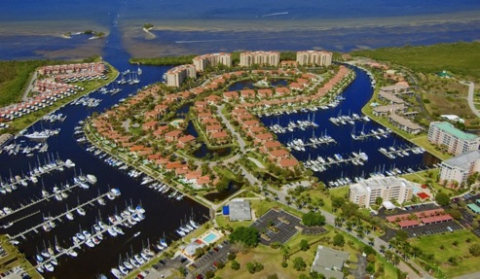

**Burnt Store Marina**

*Boca Grande*

Boca Grande, almost directly across the harbor from Burnt Store, is located on Gasparilla Island, named for the legendary Jose Gaspar, an 18th century pirate. Boca Grande is a precious community for the well heeled. To access it, cars cross a toll bridge at the north end of the island; casual visitors are rare.

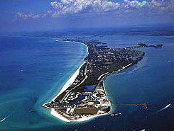

Gasparilla Island

View North from Boca Grande Pass

Charlotte Harbor was the center of the Calusa Indian empire for thousands of years. Gasparilla Island’s modern history began with a fishing settlement named “Gasparilla” at its north end. The south end of the island was uninhabited (except for a lighthouse keeper and his assistant) until the Charlotte and Northern Railway (later named the Seaboard Airlines Railroad) was constructed in 1907 to bring phosphate from Punta Gorda to wharfs at Boca Grande Pass. The advent of the railroad brought people from the north seeking warmth and the great tarpon fishing in the Pass: though inedible by all but the Calusa, tarpon grow to 150 pounds and are a great fighting fish—watching them “tailwalk” across the water after hitting a hook is a treat. Until 1969 Boca Grande was Florida’s fourth busiest port.

The railroad initiated the early growth of the village of Boca Grande, extending from the center of the island to its southern tip. By the 1970s the rail line was getting old and expensive. In 1979 it was closed, the phosphate wharfs were abandoned, and Punta Gorda phosphate was shipped north to Tampa. Also at the south end were oil storage tanks used by Florida Power and Light. These continued to be filled by tankers until 2001. The storage tanks have been completely removed, and today the unsightly mess at Boca Grande Pass is gone, only the bones of the wharfs remain.

In 1911 the Gasparilla Inn was built just north of Boca Grande Harbor. Still extant and in fine shape, it has served the elite—including U. S. presidents (especially the two Bushes). Its upscale rooms, fine dining, and fun harborside golf course make it unique along the coast. The Inn’s first competition arrived in 1929 with construction of the three-story brick Boca Grande Hotel. Built to withstand hurricanes, when the hotel closed in 1975 attempts to demolish it by explosives failed—it required the wrecking ball to bring it down.

When the railroad was discontinued in 1979 the debate about what to do with the track down the center of the island and through Boca Grande’s center led to the construction of a path for bikes and golf carts, and to restoration and preservation of the old railway depot in the town center. There is now nothing left of the island’s industrial history except an antiquated wooden railroad trestle at the island’s north end.

Once on Gasparilla Island you encounter gated communities as you drive south, until reaching Boca Grande. The town maintains an old-Florida feel. There are no malls, no theaters, no supermarkets, no gas stations, and no signs of the big city. There is a small shopping area with several restaurants. The Gasparilla Inn still dominates the area, though other private clubs have sprung up—mostly to serve the gated communities.

The Boca Grande waterfront consists of a small harbor where the Boca Grande Marina with its fine Eagle Grille provides space for boats up to 140 feet. The Grille is filled with outstanding reproductions of the owner’s fabulous collection of marine art—ships in the sailing age and carved eagles. Boaters love the newly reconstructed Boca Grande Marina, and both they and islanders love the Eagle Grille at the marina.

Just south of the Boca Grande Marina is a dilapidated building with a few boat slips. This is Whidden’s Marina, ancient when it was first built (probably by the Romans); it is not for sale until the price is right. Moderate-to-nice houses are strung along waterways dredged through the island radiating both north and south from the harbor. A nice leisurely trip through the waterways is well worth the time.

A day in Boca Grande can involve renting a golf cart at the Marina or the Inn and traveling through the uncluttered streets. As you go northward there is little but seaside and harborside housing, much of it invisible behind gates. Traveling south is more interesting: a tall lighthouse on the Gulf side, lots of housing, and, at the south end, overlooking Boca Grande Pass, an absolutely exquisite small lighthouse.

If you are driving and are willing to take the time to get to north Charlotte Harbor, you do yourself a disservice by not visiting Boca Grande.

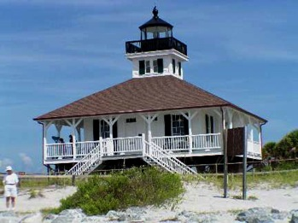

**The Boca Grande Pass Lighthouse**

*Useppa Island and Cabbage Key*

Useppa is a small island with a large history, located about five miles south of Gasparilla Island and directly east of Cabbage Key. Today it is a resort island owned by the Useppa Island Club. It has a serviceable marina, an inn with rooms and cottages, and many private upscale houses. Its only access is by boat; a small ferry runs between Bokeelia on Pine Island’s northern tip to Useppa Island and Cabbage Key.

Cabbage Key is a very small resort island with some cottages and small houses for rent, docks for transients and the ferry, and a restaurant catering to the day visitors. The restaurant is very old-Florida casual, with an unusual ambience: dollar bills cover the walls, each signed by the visitor who left it. Cabbage Key is worth a quick visit if you are already in the Useppa-Boca Grande area, and on a boat.

The visitor to Useppa is stepping back in time. When we cover the Ten Thousand Islands you will learn about Barron Gift Collier, who bought all the land now in Collier County and some land north in Lee Country. Collier bought Useppa Island in 1911 as his northern retreat; Everglades City south of Naples was his southern retreat.

Useppa has a long and interesting archeological history. Settlement dates from 8,000BC, when the water level was so low that it was part of the mainland. Pottery from 2,000BC has been found. Calusa Indians occupied Useppa before 1700 but were forced out by the Creek and Yamasee tribes by 1700. In 1784 Jose Caldez, a Cuban, began using the island as a seasonal fishing base and over time a village of sixty thatched houses grew up; he called it Josepha.

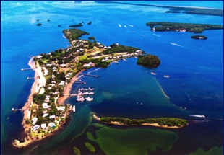

**Useppa Island**

**(Cabbage Key in Background)**

In 1833 Caldez sold the island. The first use of the name Useppa was in an 1855 nautical chart. A Customs Station was set up on the island, but the Customs officer was murdered in 1836 after the onset of the Second Seminole War. In 1850 the Army very briefly established Fort Casey on Useppa—it was abandoned in the same year. In 1875 there were two island residents and as late as 1895 only one family lived on the island.

Useppa’s modern era began in 1896 when John Roach, a Chicago businessman, bought the island and built a hotel. In 1911 Roach sold to Barron Gift Collier, of whom much more later. Collier, a frequent resident, built a hotel, tennis courts and a 9-hole golf course. Collier died in 1939 and the island was uninhabited during WWII. Hurricanes in 1944 and 1946 damaged the island and the hotel was torn down. In 1946 the Useppa Inn was built and the island reopened as a resort until 1960, when it became a U. S. Army training site for the Bay of Pigs invasion.

The island changed hands several times in the 1960’s and 1970’s. Efforts to reestablish it as a resort were unsuccessful until the Useppa Inn and Dock Company bought it in 1976. Since then it has been a successful resort and residential island, though Hurricane Charley incapacitated it for a year in 2004.

When you visit Useppa be sure you visit the Barbara Sumwalt Museum. That is a treat, with surprisingly detailed exhibits on the area’s long history. And if you want, you can join the Useppa Island Club for around $150 per month.

*Pine Island*

We’ve traveled from the east side of Charlotte Harbor to the west side. Now we shift to the central feature of the harbor—twenty-five mile long Pine Island running down its center. On its west is Pine Island Sound and the mainland, on its east are the barrier islands of Captiva and Sanibel.

The island serves as the crossroads of the large bay north of Fort Myers: its northern end marks the southern end of Charlotte Harbor, and its north-south axis splits the bay between Pine Island Sound on the west and Matlacha Pass on the east. Pine Island has about 9,000 residents, exploding to a much higher number in the tourist season. It is largely agricultural, has no traffic lights, and has the feel of a previous century. The only vehicle access is over the US78 bridge (“The Fishingest Bridge in the World.”)

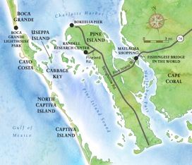

**Pine Island**

There are four population centers on Pine Island. Bokeelia—at the island’s northern tip—is a large fishing village (population 2,000) serving as the post office, general store, and transportation hub for the Charlotte Harbor islands. Pineland, the home of the Randall Research Center of the Florida Museum of Natural History is just south of Bokeelia on the island’s west coast. Pineland has an underwhelming population of 400, Just south of Pineland is Pineland Center, population 1,700. All three are north of the bridge from the mainland. St. James City, at the southern end, is another fishing village with about 4,000 people.

*Cape Coral and Fort Myers*

Cape Coral is a large planned community on the mainland across from Pine Island’s southern tip, almost due west of Fort Myers. It was started in 1957 By Gulf American Corporation, brainchild of the Rosen brothers. Cape Coral is perfectly situated—ten miles east of US75 and fourteen miles northwest of Regional Southwest Airport. Access in enhanced by several large bridges to Fort Myers.

Incorporated in 1970, Cape Coral grew rapidly as a community of retirees. But the housing boom of the 1990s brought loads of working families and the retiree representation is much diminished. It has grown to 120 square miles with a population of 155,000 in 2010. With 400 miles of canals and waterways, Cape Coral is a boaters’ place.

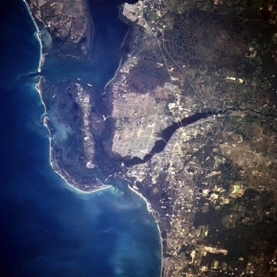

**Cape Coral (center) and Fort Myers**

*Fort Myers*

Fort Myers, with an area of 49 square miles (20 percent of it water) and a 2010 population of 62,000, is dwarfed by Cape Coral. The city is on the Caloosahatchee River that marks the western end of the Okeechobee Waterway crossing the state from Stuart, Florida. With seven locks and Lake Okeechobee in the middle, that 100-mile waterway is a treat to travel on from Fort Myers through the lake, but the leg from the lake to Stuart is a tedious slow ride past private homes.

The center of Fort Myers is the former site of Ft. Harvie, constructed in the early 1840s and abandoned until 1850 when it was revived at the outset of the Third Seminole War and renamed Ft. Myers after Col. Abraham C. Myers. At Chief Billy Bowlegs’ surrender in 1858 the Third Seminole War concluded and Ft. Myers was abandoned again. Like Lazarus, it was revived yet again at the onset of the Civil War in 1863 when the cattle-shipping business boomed to provide wartime beef.

As a Union Fort in a Confederate state, Ft. Myers’ existence was fragile. The Florida Militia attacked it in 1865 because the fort’s Union soldiers were rustling cattle from local ranchers, The Rebs were repelled after the almost bloodless daylong Battle of Ft. Myers: one Union soldier was killed and one militiaman was wounded. To celebrate its victory the Union abandoned the fort a month later.

Manuel Gonzalez and his five-year-old son, the city’s first settlers, arrived in 1866 from Key West. When Ft. Myers was incorporated in 1869 it was the second largest city in south Florida, Tampa winning the honors. The town became the seat of Lee County in 1886, promoting it to a civil status though it was still basically a cow town with cowpaddies covering the streets and cowboys covering the street ladies.

Ft. Myers’ entry into the tourist age began with the construction of the Royal Palms Hotel in 1898, when the city’s population was only 600. Initially served only by ships and ferries, access was improved over the years by the 1904 completion of the Atlantic Coast Line Railroad extension from Punta Gorda, and by the 1924 construction of a bridge from the Tamiami (“Tampa-to-Miami”) Trail (now US41). Today several major bridges link Ft. Myers to Cape Coral and points both south and north.

Ft. Myers has some sites worth seeing. In 1885—when Fort Myers population was just 349—Thomas Alva Edison arrived, and in 1887 his winter home (“Seminole Lodge”) and laboratory were completed on the Caloosahatchee River; they were given to the city in 1947. Edison’s gardens are a particular attraction. In 1916 Henry Ford, who had frequently visited Edison, purchased the adjacent estate (“The Mangoes”). Both estates are now jointly managed by a nonprofit organization, and are open to the public.

During 2000-2010 Fort Myers was among the most rapidly growing areas in the nation, with a 2010 population almost 30 percent larger than in 2000.

*The Barrier Islands: Caya Costa, Sanibel and Captiva*

Now we jump over the water to the barrier islands of Caya Costa, Captiva, and Sanibel. These well-known islands were once defined by the absence of anything except great beaches, soft winds, wildlife, and the silence of nature.

Caya Costa is just across the Boca Grande Pass at Gasparilla Island’s south end. Shielding Useppa and Cabbage Keys from the Gulf, Caya Costa is now a state park visited only by boat. Just east of Caya Costa and a mile north of Cabbage Cay is the now uninhabited island of Punta Blanca. When the islands were flourishing population centers Punta Blanca had a fish factory and a school. Both are long gone and in their place a number of privately owned fishing shacks survived until the mid-1990s. According to a friend who owned one shack with a group of avid Naples fishermen, in 1994 commercial fisherman burned the shacks in an outburst of anger against the innocent outsiders—gillnetting had just been prohibited and the recreational fishers were the targets of the local anger.

South of Caya Costa are North Captiva Island and Captiva Island. Once joined, they were separated by Redfish Pass in a 1921 hurricane. North Captiva, accessible only by boat or small plane, has about 300 houses.

Captiva is reported to have gotten its name because our piratical friend Captain Jose Gaspar kept female captives there. Its first known settler was William Herbert Binder. Binder was shipwrecked off Boca Grande in the 1921 hurricane. He drifted ashore at Captiva, liked what he saw, and stayed until his 1932 death.

Today about half of Captiva is private, with homes studding “Millionaire’s Row” on both the Gulf and Bay sides. The South Seas Resort is a large complex at Captiva’s north end, at Redfish Pass.

Crossing a short bridge from Captiva brings you to Sanibel Island. Sanibel was once separated from the mainland by a wide pass that branches northward into Pine Island Sound and eastward into the Caloosahatchee River toward Fort Myers. This left Sanibel a remote refuge from civilization. But no longer—a bridge from Punta Rassa (“Flat Point”) on the mainland was built in 1963.

The original bridge to Sanibel was a bascule bridge allowing boats to travel through. Combined with increased traffic and boat-related delays, the bridge became a traveler’s nightmare. In 2007 a high fixed bridge replaced it with more traffic lanes and no need to interrupt traffic flow for passing boats.

The 1963 bridge opened Sanibel to development and it now has many housing units, particularly at its south end. While traffic flow to the island has been improved, the pace along its single one-lane north-south axis road can be slow and frustrating.

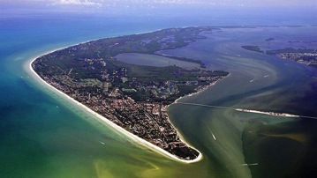

**Sanibel Island**

Sanibel’s name is of unknown origin. One story says that the ubiquitous Jose Gaspar named it after his lover Sanibel back in Spain. Another says that Ponce de Leon named it after Saint Isabel, the Spanish Queen’s saint. Whatever the origin, in 1832 the first attempt to settle the island, by the Florida Peninsular Land Company, failed to garner interest in living on the island. After the 1862 Homestead Act a small community formed, and in 1884 the Sanibel lighthouse was erected. The entire island was incorporated in 1974 as the City of Sanibel.

Sanibel’s main interest for the visitor is the J. N. “Ding” Darling Wildlife Refuge created in 1976. The Bailey-Matthews Shell Museum is also a popular venue.

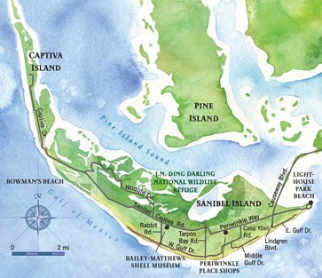

**Sanibel and Captiva Islands**

Punta Rassa on the mainland is between Ft. Myers and Ft. Myers Beach. It was first inhabited by the Spaniards in the mid-16th century, who used it as a shipping point for cattle raised around Punta Gorda. In the 19th century it was a cow town where cattle were collected for shipment to Cuba. During the Seminole Wars Ft. Delany was built at Punta Rassa, but it was abandoned after a hurricane in 1841. Search for a safer site settled on a site up the Caloosahatchee River: Ft. Harvie was built up 1in 1841 at the site of modern Fort Myers. Punta Rassa is now the site of large high-rise condominiums.

*Naples*

Situated about forty miles south of Fort Myers, Naples might be called “the jewel on the back of the toad.” While the rest of Southwest Florida is rustic, retired, and of relatively low income, Naples shines like a neon light—it has everything! The 2000 census (which counts only Florida residents) say it has 33,000 people, but greater Naples is vastly more populated, and the winter population at any time is well above 300,000. One of my earliest memories was as a six-year old visiting my grandmother in Naples in 1949. There was virtually nothing there except the Naples Beach and Golf Club; the population in 1950 was about 1,000.

First settled in 1886 by Kentuckians John Stuart Williams (Confederate General and U. S. Senator) and Walter N. Haldemann (owner of the *Louisville Courier-Journal*), Naples was a fishing village not easily reached from any direction. In 1888 it had about 80 people, all involved in fishing.

In 1927 the railroad was extended from Fort Myers, and in 1928 Barron Collier completed the Tampa-to-Miami Trail. The doors were open, but the depression and WWII delayed the flood of visitors. Naples was also mosquito-ridden, hot, and humid in the days before air conditioning. In 1943 a U. S. Army Air Training Field was established in Naples—the only significant new activity. Cadets, familiar with the Florida city named after beautiful Naples, Italy, were a source of pent up demand for Naples housing in the years after the war.

After the war Naples began to grow: from 1,253 in 1940 it grew to 9,133 in 1960; 13,564 in 1970; 26,180 in 1980;…; 32,902 in 2000. This is not the Metropolitan Area of Collier County—just Naples City. Hurricane Donna in 1960 marked a turning point for the city. Its devastating damage allowed old stores, houses, and roads to be rebuilt to satisfy the needs of an increasingly sophisticated clientele seeking modern amenities. And air conditioning arrived! The result was a boost in Naples image as a place to visit. The shift of the Collier county seat to Naples from Everglades City added impetus.

What can you do in Naples? Well, anything you want. The Naples Zoo, owned by the city, is a popular venue for families. Tin City on Naples Bay has several restaurants and knickknack stores. There are shops, art galleries, and restaurants on Fifth Avenue, where the Tamiami Trail veers east, and others at Third Street in Olde Naples. The long Naples Pier is a popular spot for fishing and sunset viewing. And then there are miles-long white sand beaches.

A popular activity in Naples is house viewing. Three areas seem to get the most attention: Royal Harbor on the east side of Naples Bay, Aqualane Shores at Olde Naples, and—most of all—Port Royal, between Aqualane Shores and Gordon Pass that connects Naples Bay with the Gulf.

Started in the early 1950’s by Glenn Samples, a developer who carved fingers of water into a pristine expanse of mangroves, Port Royal properties sold for $15,000 in 1954; houses were low one-story Florida-style bungalows. Today a building lot sells for an easy $5-10 million, and some are listed at $50 million. And many of the houses are gigantic testaments to the owner’s ego and poor taste. There is always something available—the very rich of a certain age come to Port Royal and build a dream house. Within a few years they die or sell, and the next buyer tears the dream house down to build their own dream house. If you want proof that taste and money are inversely correlated, drive through Port Royal. But don’t expect a quick trip—the one lane streets are clogged with the vehicles of landscapers and construction crews, and with walkers and bicyclists.

**This Page Intentionally Left Blank**

**The Mosquito Coast: The Ten Thousand Islands**

This large area of small and mostly uninhabited mangrove keys is the western edge of Everglades National Park and the entry to the narrow inland waterway that runs from east of Everglades City down past the Shark River to the city of Flamingo at Florida’s southwestern tip. That waterway is navigable only by kayaks, canoes, and small boats: heavily shaded by overhanging trees, it has occasional platforms for a rustic overnight stay by boaters. Mosquito lovers will adore it.

Native Americans have occupied the Ten Thousand Islands area since at least 10,000BC. By the 17th century there were two tribes in southern Florida: the Tequestas lived in a single large village in the Miami area, the more numerous Calusas lived in 30 small villages in the Ten Thousand Islands (as well as in the Charlotte Harbor area). For the Calusas, life at sea level was constantly threatened by storm surges—a hurricane with a surge of 10-15 feet or more completely covered their villages and destroyed cropland. To combat this, Calusa villages were built on narrow waterways cut into the interior, or on mangrove islands built up by oyster shell discards (shell mounds). Chokoloskee Island, connected to Everglades City by a causeway, is the most prominent shell mound; it has a maximum height above water of about 20 feet, and is sited on shellfish exoskeletons topped by rough soil.

By 1800 Creek Indians from the north had moved south and absorbed the Tequestas and Calusas. The Seminole nation was formed by the original Creeks and the absorbed Indian tribes, by escaped slaves, and by whites (including Civil War soldiers who had migrated to the area). In 1842, after the Second Seminole War, the Seminoles were removed to Oklahoma; those that escaped the removal were pushed into the deep interior of the Everglades. Many of these were rounded up in the Third Seminole War that ended in 1858. By 1870, when the city of Everglades was first settled, the area was almost entirely the residue of the Seminole nation plus a few alligator hunters, plumers, and fishermen. Included among these were some “desperados” seeking distance from the law (the sheriff was 100 sea miles away in Key West).

There are three historic communities in the Ten Thousand islands: Marco Island, the northern port to the area (population about 16,000), Everglades City (population about 500), and Chokoloskee (population 400). The Mosquito coast extends as far south as uninhabited Cape Sable.

*Marco Island*

Marco Island is bordered by the Big Marco River on the North and by Caxambas Pass on the south. At the lower right is Goodland, an Old Florida fishing village off the beaten route. South of Caxambas Pass is the Ten Thousand Islands.

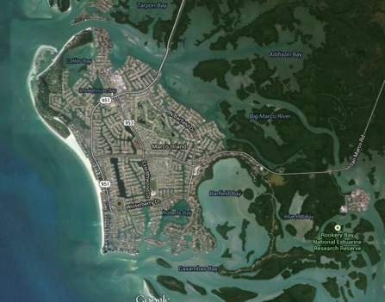

**Marco Island in 2010**

Calusa Indians (of whom more later) occupied Marco Island prior to the arrival of Spanish explorers, who arrived circa 1550 and named it “La Isla de San Marco.” The first known settler on Marco Island, William Thomas Collier, settled the town of Marco at the island’s north end in 1870. Collier grew vegetables and other crops for the Fort Myers and Key West markets, transporting the goods by boat.

In 1895 Collier’s son, William D. “Captain Bill” Collier, uncovered Calusa relics on his property, and in the following year Frank Hamilton Cushing led a world-famous archeological dig on the island. Those relics are now at the Smithsonian Institution preparing for transfer to the new Marco Island Historical Museum. In 1896 Captain Bill built the first hotel on the island, at the fishing village of Goodland; that is now the site of the Olde Marco Inn.

After fishing, pineapples were the major product of Marco Island. In the early 1900s clam digging became a major industry on Marco Island and in the Ten Thousand Islands area. The Burnham Clam Factory opened in 1903 and closed in 1929; the Doxsee Clam Factory operated from 1911 to 1947 (when the Everglades National Park was dedicated). Clam dredges patrolled the Ten Thousand Islands, ripping up giant areas and pulling out millions of pounds of clams: The dredging ended when the Everglades National Park was dedicated—though by that time the clam population and the industry’s profitability had been greatly reduced.

In 1922 Barron Gift Collier (no relation to the Colliers of Marco Island) bought large parcels of Marco Island. He incorporated the town of Collier City in 1927. Collier City was disbanded in 1957, having had only one mayor in its thirty-year history (Doxsee, owner of the clam company). At the same time Collier bought the land that became Everglades City to the south.

A ferry service began in 1912 from Isles of Capri on the north side of the Big Marco River to Marco Island. In 1927 Barron Collier connected the Isles of Capri and Fort Myers by a train running along the present US 951; goods were then transported to Marco by ferry. The island was reached only by boat until 1938, when a wooden vehicle bridge was built on Route 92 at Goodland; both the ferry service and the trains service to north Marco were discontinued in 1944 after the Goodland bridge had taken away most of their traffic. In 1975 that wooden bridge was replaced by the current Goodland bridge.

In early 1962 the Mackle brothers’ Deltona Corporation bought large portions of Marco Island from Barron Collier’s heirs. At that time all residents were clustered into two villages: Marco at the north end, and Goodland at the southeast end. The Mackles developed a master plan to convert most of the island from remote farms to a major population center. At the official opening on New Years Day, 1965, there were only twelve houses constructed for viewing by potential residents. Interest in the island was high and the Deltona Corporation quickly went through its first few phases, which included the 1969 construction of the S.S. Jolley bridge along US951; this shifted the island’s primary access route from Goodland to north Marco Island.

In 1976 the Corporation was dealt a near fatal blow: its last two phases proposed development of the land along a high ridge along Barfield Bay and Big Key on the west side. Environmental groups stood in opposition, and the U. S. Corps of Engineers rejected the permits. Since money from earlier phases had been used to prepare for these phases, the company became strapped for cash. A six-year legal battle ended in a 1982 U.S. Supreme Court decision to uphold the Corps of Engineers. The company was on the edge of bankruptcy but it survived from resources at other development sites. It gave 7,000 acres of the now-useless land to conservation.

Today much of Marco Island’s 17 square miles is residential housing, both single family and condominiums. The city of Marco has hotels and large condominium buildings running along the Gulf coast and on the banks of the Little Marco River at the Gulf end. In 2010 its population was a bit over 16,000 (excluding the many tourists, absentee owners, and renters). This city extends from the Marco River at the island’s north end to Caxambas Pass at the south end, and as far east as Barfield Bay. The remote town of Goodland at the island’s southeast end is worth visiting as one of the very few old-time fishing villages still extant.

*Everglades City*

Everglades City can be reached from Naples or Miami by taking US41 (the old Alligator Alley) to US29, then turning south for a very short distance. It has, arguably, the most interesting history in Southwest Florida.

In 1870 William Smith Allen was the first settler in what is now Everglades City. Allen and his family, who hailed from Key West, grew vegetables along the Allen River (now the Barron River) for sale in Key West. In 1889 Allen sold his house and the area around it to George Storter Jr. and his brother, Robert Bembury Storter. The Storters established a trading post, converted Allen’s house to temporary lodging for Indians and others who came to trade, and grew sugarcane for the Key West market. In 1893 they established the Post Office for “Everglade, Florida,” thus naming the area; that name was chosen after the Postmaster General rejected the name “Chokoloskee.”

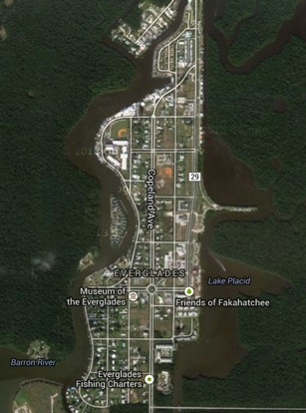

**Everglades City**

In 1921 Barron Gift Collier, a Tennessee advertising tycoon (the first to put advertising posters in trolley cars) bought the Storter land along with one million acres of surrounding land. A visionary, Collier renamed the city “Everglades City” and formed the Collier Corporation, which developed plans for a modern city, with electric power, a trolley system, other modern amenities, and, of course, residential housing. Collier also rebuilt the Storter Trading Post (once the Allen house) into the Everglades City Rod and Gun Club, which attracted hunters and fishermen from the north, as well as such luminaries as U. S. presidents and businessmen like Henry Firestone, and the inventor Thomas Alva Edison.

The Ten Thousand Islands had long been part of Florida’s Lee County, which had been formed from Monroe County in 1887. Lee County extended from Fort Myers on the north down to the Shark River area at the south. In 1923 Collier made a proposal to the state: if the state allowed his million acres to be established as a separate county, he would finish the Tamiami Trail that had been started in 1915 at Tampa and only went as far south as Naples. This was an offer the state couldn’t refuse —in exchange for renaming a large parcel of its land, Florida would gain a connection between its east and west coasts. Thus, Collier’s land became Collier County and, in 1928, the rest of Tamiami Trail was finished. The primary winner was Barron Collier, who at the end of the day had both a county with his name and a road to Miami over which prospective home buyers could travel.

In 1960 Everglades City, then Collier County’s seat, had a population of about 1,800 (including Chokoloskee) while Naples, 40 miles north, had about 9,100 souls. After Hurricane Donna devastated both Everglades City and Naples in 1960, Naples was rapidly rebuilt with modern roads and buildings; Everglades City was slower to rebuild and Naples began to grow rapidly while Everglades City dwindled. In 1961 Naples became Collier County’s seat. In 2000 Naples had a population over 33,000; Everglades City-Chokoloskee was down to 800. These counts include only Florida residents, excluding the many absentee landowners.

Everglades City is the headquarters of the Everglades National Park. First formed in 1934, its progress was delayed by the Depression and World War II until its dedication 1947, after which federal money became available and the life of the residents dramatically changed. Fishing became restricted, a problem for a community whose livelihood was from the sea. Houses that had been built on the mangrove islands were condemned and destroyed, a problem for those who had invested in their homes and were displaced. These changes and their effects are documented in Peter Mathiesson’s *Shadow Country* trilogy.

The result of the Park’s policies was that Everglades City atrophied further. The remaining population turned to smuggling drugs. Bales of marijuana called “square grouper” were brought by boat or plane from the Bahamas or South America, offloaded onto small boats out in the Gulf, and transported to trucks on land. In 1983 the Department of Justice’s Drug Enforcement Agency staged a massive raid on Everglades City and Chokoloskee, arresting something like 75 percent of the adult males. A Naples judge was also caught up in the raid. Once again, government had arrived to help the people! I first learned of this from a fishing guide I used in the Everglades City area: he had been the lead DEA agent in the raid and had come to know and admire many of the local characters (among them the famous Loren G. “Totch” Brown).

Today Everglades City is a sleepy village that has little going for it. Attempts to revitalize the city have failed. A large RV park with power, sewerage, and docks, built in the 1990s to attract tourists, now sits vacant. In 2005 Hurricane Wilma flattened a housing development under construction on the Barron River: its remnants are on the starboard side as you turn into the Everglades City channel. More successful has been the creation of the Museum of the Everglades, documenting Everglades City’s history.

Still, Everglades City is a place to visit. Only a 45-minute drive from Naples, you can lunch at the Rod and Gun Club on the Barron River (cash only!), visit the well-presented Museum of the Everglades, take an airboat ride, take Park Service boat tours of the islands, see dolphins, have a fine day in the sun, and explore an area that might have been a contender. You can also visit Chokoloskee Island.

Then get back to Naples.

*Chokoloskee*

As you would expect, the history of Chokoloskee and Everglades City are tightly interwoven. However, Chokoloskee has bitten deeper into the national senses, in large part because of the story of Mr. Watson.

Chokoloskee, located at the Everglades City side of ten-mile long Chokoloskee Bay, remained uninhabited between the Calusa era and 1874, with the exception of occasional campsites of federal troops intent on harassing the remaining Seminoles. In 1874 The Santinis—no, not the Great Santinis but Adolphus Santini, his brother, and their parents—became Chokoloskee’s first settlers. By 1882 there were only three additional families. In 1886 Charles (“C.G.”) McKinney arrived. Their livelihood was from fishing, pluming (slaughtering entire rookeries for the feathers) and farming, including cutting buttonwood trees to make charcoal. In 1891 McKinney was permitted to establish a post office for the town of Comfort, a name soon changed to Chokoloskee.

Perhaps the most prominent arrival was Charles Sherod “Ted” Smallwood and his family. The Smallwoods arrived in 1897 when there were still only five families on Chokoloskee Island. In 1899 (after a run-in with Mr. Watson) the Santinis moved to Key West. Smallwood bought their property and embarked on a series of land purchases that left him as the island’s main landholder. Smallwood’s living was from growing tomatoes, and buttonwood, hunting alligators for meat and hides, and a small store operated in his home. From Smallwood we have what little written history there is of Chokoloskee, including the outlines of Mr. Watson’s story.

In 1906 McKinney retired and Smallwood became postmaster. Smallwood had been running a small store from his house, from which he actively with the Indians. In 1906 he built a large General Store on Chokoloskee Bay, where he continued to trade with the Indians: their alligator hides and furs for his food, utensils, and alcohol. The Indians would pole their wide flat-bottom canoes across the very shallow Chokoloskee Bay and land at a small beach by the store.

The original Smallwood Store was destroyed in the massive Hurricane of 1910, but it was quickly rebuilt on stilts and has survived many subsequent hurricanes. After Smallwood retired in 1941 his daughters ran the post office; after he died in 1951 his daughters ran the store. In 1974 the store was placed on the Registry of Historical Places. It closed as an operating entity in 1982 and in 1987 it reopened as a museum. The Smallwood Store is still open to the public, and it is well worth a visit for its ambiance and its displays of all sorts of goods sold around the turn of the century.

Ted Smallwood’s store plays a role in the story of Mr. Watson. In the 1870s Edgar (“E. J.”) Watson was in his late teens living with his family in Ft. White, Florida. He got into trouble and fled to the Oklahoma Territory, where he reputedly killed Belle Starr, a female outlaw. He then returned to Florida where he is reported to have killed a man in self-defense in the town of Arcadia. Sometime in the 1880s Watson moved to the Ten Thousand Islands, possibly because the nearest sheriff was far away in Key West.

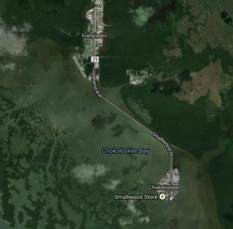

**Everglades City to Chokoloskee**

Watson settled on a very remote island about ten miles southeast of Chokoloskee. The island, which he called “Chatham Bend,” is located in the Lost Man’s River area at the junction of the Huston and Chatham Rivers.

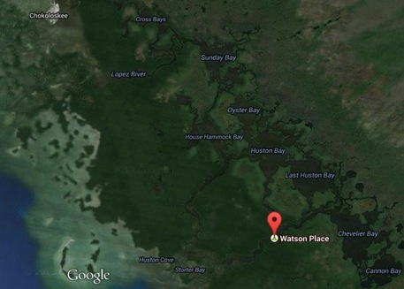

**Chokoloskee to Watson’s Place**

Watson built a large house at Chatham Bend and started a successful sugar cane plantation, hiring migrant workers to grow the cane, cut the cane, and rend it into maple syrup for sale in Key West. He was the most successful sugar cane grower in a region of failed sugar cane farms. Watson bought another island only to discover that two men were squatting on it. After they refused to leave they were found murdered. As you might expect, Watson was the main suspect but nothing could be proved.

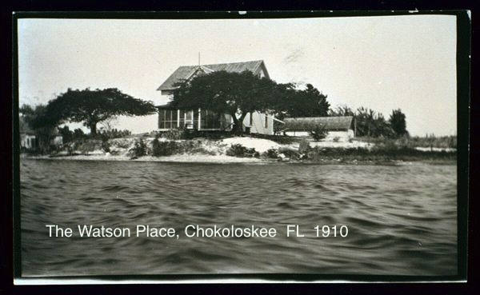

Watson also got a reputation for running a rough shop at Chatham Bend. He would hire cold-blooded killers as overseers for his workers, then have a “Watson Payday” for his workers at the end of the season—when their pay came due he would kill them and bury the bodies on remote keys in the area; or so the rumors said. So folks around Chokoloskee found Watson a problematic neighbor. While they liked him personally—he was handsome, quiet, sober, and considerate when he visited Chokoloskee, he had a hard edge and a bad reputation even before all the bodies started appearing.

In 1910 things came to a head. Two bodies of Watson employees were found in the Chatham Bend area while Watson was up north in Fort Myers. This was just after the 1910 hurricane had flooded Chokoloskee Island leaving only a small dry area for the huddled residents. Local nerves were jangled and suspicion fell on one of Watson’s overseers, a rascal named Cox. When Watson returned to Chatham Bend he visited the still waterlogged Smallwood Store, where he was told about the deaths and given an ultimatum: it was either Cox or Watson—bring back Cox’s body or Watson would pay the fare.

Watson went back to Chatham Bend and returned to Smallwood’s a few days later. All the town’s menfolk were gathered at Smallwood’s to greet him after hearing the sound of his one-cylinder outboard engine approaching. As his boat landed at the Smallwood Store beach he reported that he had killed Cox but the body had floated away and couldn’t be recovered. Frontier justice ended the Watson saga—he was shot on the spot by a simultaneous volley from all of the men. This (finally) brought the sheriff from Key West, but the exact killers could never be determined. To this day Chokoloskee is very tight-lipped about its most historic event. Since many of the current residents are descendants, one suspects that “the truth is out there,” as they said on the X-Files.

One can visit Watson’s place at Chatham Bend, though at some risk: the route is very shallow, the current runs hard, and the path winds in a tortured meander. I did it on a boat with a three-foot draft by going up the Huston River from the Gulf, and almost got stuck on the return for a mosquito-filled night. It is a place where local knowledge prevails—if you are a tourist don’t try it on a powerboat without a guide—canoes and kayaks only.

The rewards of the trip are scanty. There is very little left at Chatham Bend. The house, the boathouse, and the worker’s lodgings were all burned by the Park Service in the early 1950s in their effort to return the Park to its natural origins. All I found were the remains of an old cement cistern, an old cement vat for boiling down sugar cane, and an open area used by canoers and kayakers as an overnight camp. The rest is covered by dense vegetation.

**This Page Intentionally Left Blank**

**The Empty Coast: Cape Sable to Flamingo**

Little can be said about Cape Sable, Florida’s tip, except that it is empty. Most of it is incorporated into Everglades National Park, which prohibits permanent residents. People found in the area are typically canoeing or kayaking on the many miles of waterway dotted by occasional campsites.

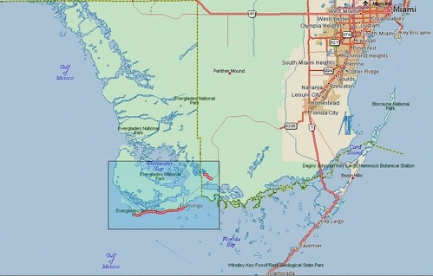

**Cape Sable**

First settled in 1893, Flamingo is the southern headquarters of the Everglades National Park. The only road to Flamingo is a Park road from Homestead. Its early residents—fishermen, smugglers, hideaways—were relocated when the Park was dedicated in 1947; today only Park personnel live there Dyed-in-the-wool fisherman visit the town, as do travelers on the Waterway down from the Ten Thousand Islands. There is a lodge, a restaurant, a gift store, and a marina.

Flamingo is the destination of the 100-mile waterway from Everglades City, passable by canoes, kayaks, and very low shallow-draft powerboats. The waterway is dotted by campsites for the multi-day trip.

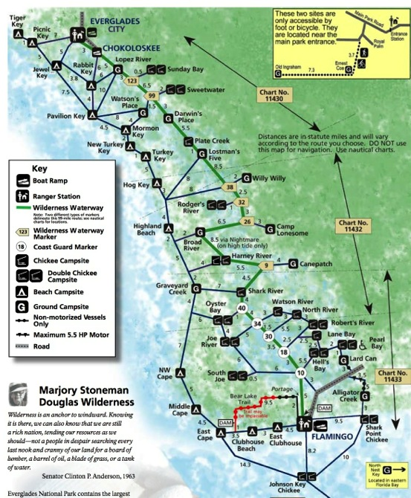

**References**

Brown, Loren G. “Totch.” *Totch: A Life in the Everglades*, University Press of Florida,

1993

Mathiesson, Peter. *Killing Mr. Watson*, Random House LLC, 1990.

______________. *Lost Man’s River*, Random House LLC, 1997.

______________. *Bone by Bone*, Random House LLC, 1999.

______________. *Shadow Country*, Random House LLC, 2010. (trilogy in one volume)

Smith, Patrick D. *A Land Remembered*, 1984.

Tebeau, Charlton. *The Story of the Chokoloskee Bay Country, with the Reminiscences of*

*C. S. “Ted” Smallwood*, Copeland Studies in Florida History, Florida Flair Books,

1976